Are you:(tick one) |  | Female |  |  | Male |  | Non-binary |  | Prefer not to say
 | Prefer to self-describe ……………………………………………………………………………………….
What is your sexual orientation? (tick one)
Bisexual Gay Man Gay Woman/Lesbian Heterosexual/Straight Prefer not to say

Prefer to self-describe ……………………………………………………………………………………….
What age are you? (tick one)
 | Under 16 | 30-34 |  |  |  |  | 50-54 |  | 70-74
 | 16-19 | 35-39 |  |  |  |  | 55-59 |  | 75-79
 | 20-24 | 40-44 |  |  |  |  | 60-64 |  | 80 or older
 | 25-29 | 45-49 |  |  |  |  | 65-69 |  | Prefer not to say
How would you describe your ethnicity? (tick one)
Arab |  |  |  | Black or Black British: African |  |  |  | Mixed:Other/Multiple ethnic background
Asian or Asian British: Bangladeshi |  |  |  | Black or Black British: Caribbean |  |  |  | White: British
Asian or Asian British: Chinese |  |  |  | Black or Black British: other |  |  |  | White: Gypsy or Irish Traveller
Asian or Asian British: Indian |  |  |  | Mixed: Asian and White |  |  |  | White: Irish
Asian or Asian British: Pakistani |  |  |  | Mixed: Black African and White |  |  |  | White: Other
Asian or Asian British: other |  |  |  | Mixed: Black Caribbean and White |  |  |  | Other
 |  |  |  |  |  |  |  | Prefer not to say
What is your country of origin? ………………………………………………………………………….
Do you identify as being a D/deaf or disabled person, or have a long term health condition? (tick one)
Yes, Limited a lot |  |  | No |  |  | Prefer not to say
Would you describe yourself as having an invisible disability? Yes No
How would you describe your income? High Medium Low

Which region do you live in? ………………………………………………………………………………..

Thank you.
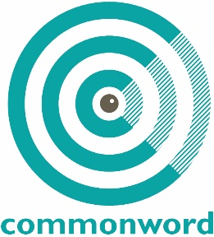
Commonword Diversity Monitoring Form

We are committed to equality of opportunity for all job applicants regardless of gender, marital status, sexual orientation, race, ethnic or national origin, trade union membership, political or religious belief, disability or age.
The information you provide will be treated in the strictest confidence and protected from mis-use and will not form part of your application. It will be used only for the purpose of monitoring our diversity and employment policy.

